Last Updated: 8/18/2021
This QRG outlines the Pay Change – Pay Increase process for an employee in SuccessFactors.
Contents
What is a Pay Increase? 1
Pay Increase Process 1
Access SuccessFactors 2
Searching for an Employee 2
Taking Action 3
Processing a Pay Change – Pay Increase 5

What is a Pay Increase?
A Pay Increase is an increase to an employee’s salary or hourly rate. All Pay Changes must be made in accordance with University Policy, Pay Practices, and Pay Rates/Scales.

Pay Increase Process
The Initiator processes the Pay Increase in SuccessFactors. Once complete, it is routed to the Department Head and Budget Approver via the workflow process. If necessary, it will be routed to HR Compensation for further approval.
Note: Undergraduate and Graduate pay changes do not route ot the Department Head for approval.

Access SuccessFactors
Visit OneCampus and select Employee Launchpad or from the Employee Self-Service web page click SuccessFactors  Log in using Purdue Career Account ID and Password. | https://one.purdue.edu/  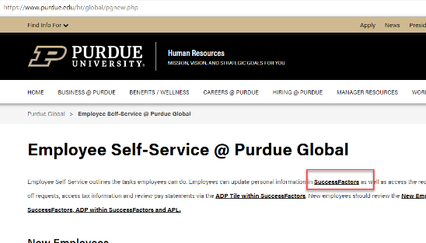  https://www.purdue.edu/hr/global/pgnew.php

Searching for an Employee
- From the SuccessFactors home page, locate the Search field on the navigation bar.  - In the Search field, type the employee’s name.  - Multiple matches may be displayed.  Scroll to select the correct name, click to select. |  | 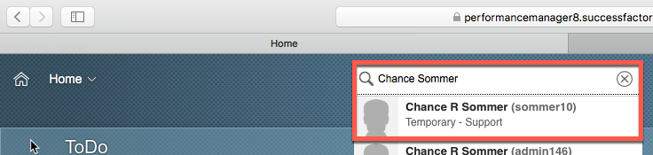
This will display the employee’s Employee File. | 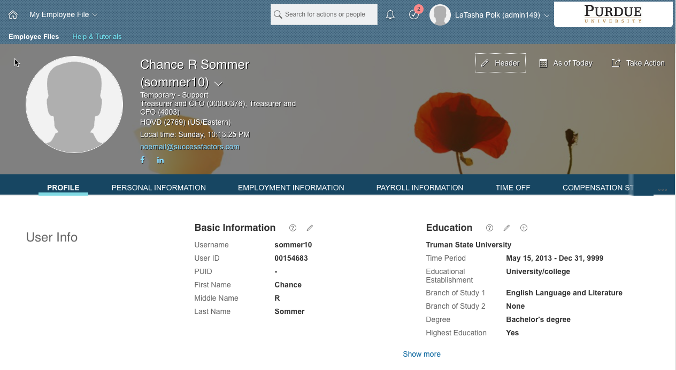

Taking Action
From the Employee Profile.  Click Take Action to display action options.  Once the action options are displayed, select Change Job and Compensation Info to begin processing the Pay Change – Pay Increase. | 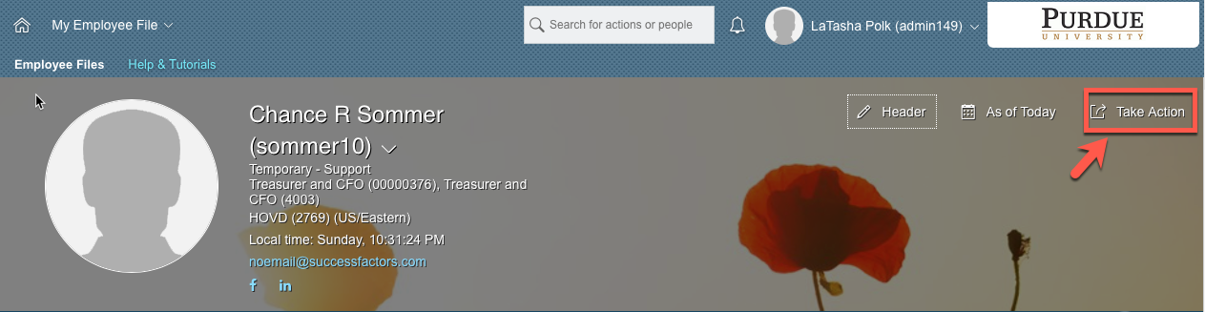  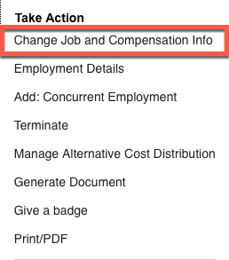
The other option is found on the SuccessFactors home page.  Once the employee has been located, hover over their name to view their employee information on a separate pop up window.  Next, click Take Action to display action options. | 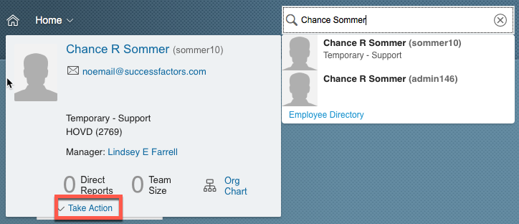
Once the action options are displayed, select Change Job and Compensation  Info to begin processing  the Pay Change  – Pay Increase. | 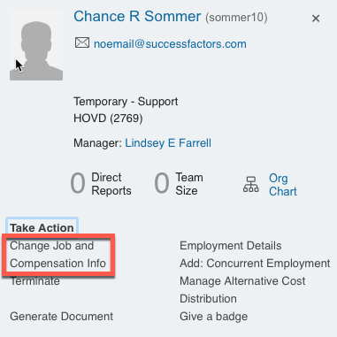

Processing a Pay Change – Pay Increase
Click the checkbox to select Compensation Information.  Next, manually input the date (mm/dd/yy) the job change should take effect or click the Calendar icon to display a calendar.  Click the day the Pay Change – Pay Increase change should take effect to populate the date field. | 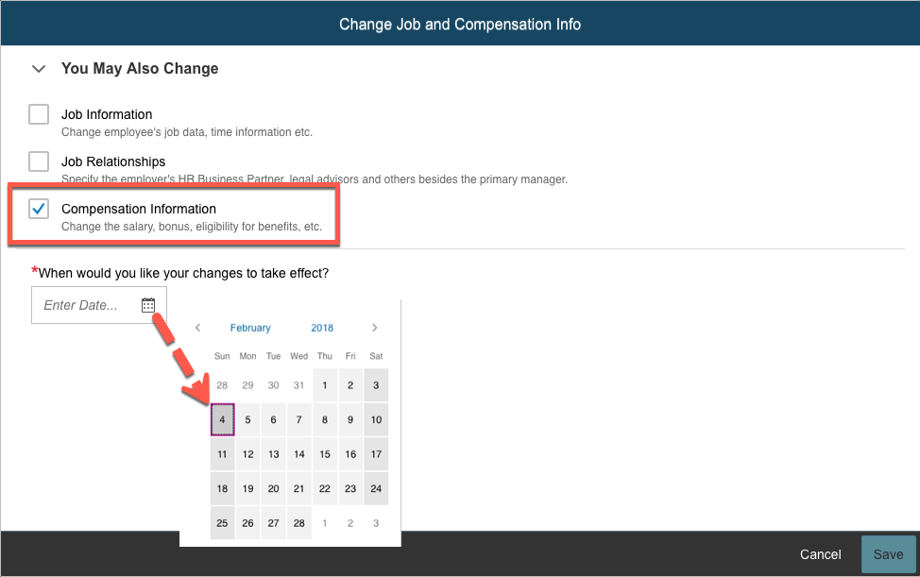
Once the date field has been populated, the field options associated with all selected change types are displayed. | 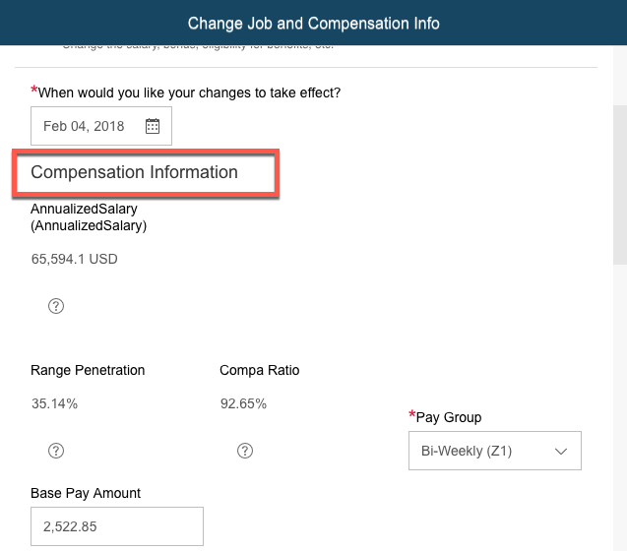
Scroll down to the Amount field under the Compensation header.
Enter the new amount in the Amount field.

Alternatively, use the calculator to change the current amount by a specific percentage.
- Click the Calculator icon to display the Change Calculator box.
- Type either the value of the change in the Change Amount field or the percentage of the change in the Change Percent field.
- The Total Amount field will be auto-populated.
- Click Save on the Change Calculator box.
Click Save on the Change Job and Compensation Info box.
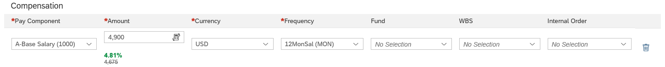
The Confirmation Request box is displayed.  Enter any comments to be shared with other workflow participants in the comment box.  Click Confirm.  A notification is sent to the approvers.  Note: Click show workflow participants to display the names of the individuals responsible for the review and approval process. | 